More than 125,000 containers of all types – At your disposal ! Customer Information Sheet
We are ready to lift your cargo, and if you want to ship shoes or shallots, transport tubes or tubas, move melons or men’s suits, you will always find the right container solution with us. Whether you want it cool, or ventilated, prefer it to be big, small or standard. We can meet you needs.
Just give us the word, and we’ll find the right room for your cargo.
 | EQUIPMENT | INTERIOR DIMENSIONS | DOOR  OPENING | TOP  OPENING | TARE  WEIGHT | CUBIC  CAPACITY | CONTAINER  PAYLOAD
Dry Freight Containers  A dry freight container is a closed box with one set of doors, and is designed for general cargo. Dry containers are made of aluminums or steel, and come in 20’/40’/45’ lengths and 8’6/9’6 in height.  UFS line also offers hangertainers which are aluminums and steel containers adapted to accommodate garments on hangers. They are equipped with special beams below the root which enable garments to be taken directly from the manufacturer’s plant to the consignee’s warehouse or store without further packing. | 20’ DRY FREIGHT CONTAINER  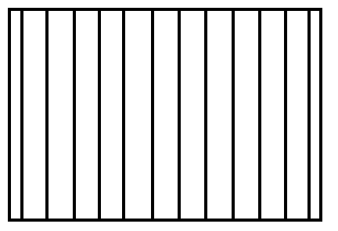 | L:5,919 mm  W:2,340 mm  H:2,380 mm | W:2,286 mm  H:2,278 mm |  | 4,189 LBS  1,900 KGS | 1,165 CU. FT.  33.0 CBM | 48,721 LBS  22,100 KGS
 | 40’ DRY FREIGHT CONTAINER | L:12,045 mm  W:2,309 mm  H:2,379 mm | W:2,289 mm  H:2,278 mm |  | 6,799 LBS  3,084 KGS | 2,377 CU. FT.  67.3 CBM | 60,397 LBS  27,396 KGS
 | 40 HIGH CUBE DRY CONTAINER | L:12,056 mm  W:2,347 mm  H:2,684 mm | W:2,340 mm  H:2,585 mm |  | 6,393 LBS  2,900 KGS | 2,684 CU. FT.  76.0 CBM | 65,256 LBS  29,600 KGS
 | 45’ HIGH CUBE DRY CONTAINER | L:13,582 mm  W:2,347 mm  H:2,690 mm | W:2,340 mm  H:2,585 mm |  | 8,598 LBS  3,900 KGS | 3,026 CU. FT.  85.7 CBM | 63,052 LBS  28,600 KGS
Reefer Containers  Reefer Containers-Fresh to you from around the world  The reefer containers are made of aluminums with stainless steel lining, to ensure high payload capacity.  A large percentage of our containers feature micro-processor controlled refrigeration machinery which provides instant error detection, reporting of malfunction area and temperature deviation alarm, permitting our onboard reefer specialists to act immediately. The remote monitoring system will ensure central registration of all vital data.  Reefer containers are available with: Humidity control to ensure correct relative humidity inside the container; Data loggers for monitoring cold treatment: and Controlled/modified atmosphere to prolong the shelf life of chilled products. | 20’ REEFER CONTAINER  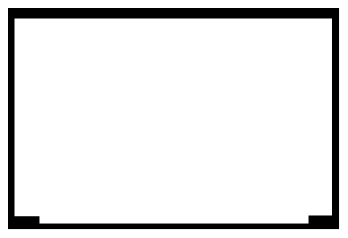 | L:5,428 mm  W:2,266 mm  H:2,240 mm | W:2,286 mm  H:2,188 mm |  | 6,482 LBS  2,940 KGS | 971 CU. FT.  27.5 CBM | 53,043 LBS  24,060 KGS
 | 40’ REEFER CONTAINER | L:11,207 mm  W:2,246 mm  H:2,183 mm | W:2,216 mm  H:2,118 mm |  | 10,670 LBS  4,840 KGS | 1,939 CU. FT.  54.9 CBM | 56,526 LBS  25,640 KGS
 | 40’ HIGH CUBE REEFER CONTAINER | L:11,628 mm  W:2,294 mm  H:2,509 mm | W:2,290 mm  H:2,535 mm |  | 9,766 LBS  4,430 KGS | 2,363 CU. FT.  66.9 CBM | 61,883 LBS  28,070 KGS
 | 45’ HIGH CUBE REEFER CONTAINER  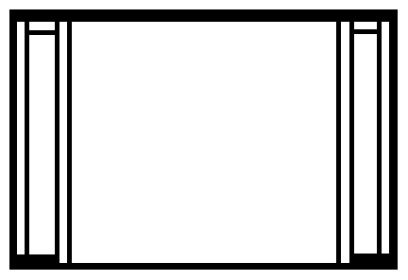 | L:13,102 mm  W:2,294 mm  H:2,509 mm | W:2,290 mm  H: 2,509 mm |  | 11,464 LBS  5,200 KGS | 2,663 CU. FT.  75.4 CBM | 60,186 LBS  27,300 KGS
Open Top Containers  An open top aluminums or steel container allows cargo to be lowered into the container by a crane if the cargo is not suited for loading through the doors. It is equipped with removable roof bows and a tarpaulin cover. Also the door header can be removed. Bull rings for securing are mounted on the floor. | 20’ OPEN TOP CONTAINER  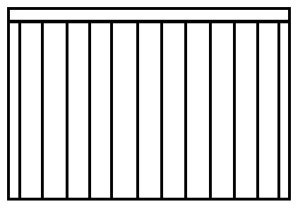 | L:5,919 mm  W:2,340 mm  H:2,286 mm | W:2,286 mm  H:2,251 mm | L:5,425 mm  W:2,222 mm | 4,793 LBS  2,174 KGS | 1,116 CU. FT.  31.6 CBM | 48,117 LBS  21,826 KGS
 | 40’ OPEN TOP CONTAINER | L:12,043 mm  W:2,340 mm  H:2,272 mm | W:2,279 mm  H:2,278 mm | L:11,585 mm  W:2,162 mm | 9,480 LBS  4,300 KGS | 2,260 CU. FT.  64.0 CBM | 57,720 LBS  26,181 KGS
Flat Rack Containers  A flat rack container is a unit which consists of a base frame and two end walls, or alternatively, four individual corner posts. Flat racks are ideal for transporting heavy machinery and pipes, since they can be loaded form the top or from the sides. The end walls/corner posts can be either fixed or collapsible. | 20’ FLAT RACK CONTAINER  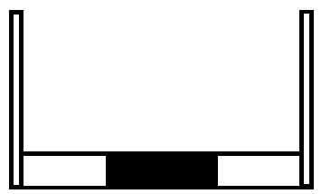 | L:5,662 mm  W:2,438 mm  H:2,327 mm |  |  | 5,578 LBS  2,530 KGS |  | 47,333 LBS  21,470 KGS
 | 20’ COLLAPSIBLE FLAT RACK CONTAINER | L:5,946 mm  W:2,126 mm  H:2,233 mm |  |  | 6,333 LBS  2,900 KGS |  | 59,740 LBS  27,100 KGS
 | 40’ FLAT RACK CONTAINER | L:12,080 mm  W:2,438 mm  H:2,103 mm |  |  | 12,081 LBS  5,480 KGS |  | 55,115 LBS  25,000KGS
 | 40’ COLLAPSIBLE FLAT RACK CONTAINER | L:12,080 mm  W:2,126 mm  H:2,043 mm |  |  | 12,787 LBS  5,800 KGS |  | 64,374 LBS  29,200 KGS
Open side Open top Containers  The open side/open top container is designed for transporting “live” products such as potatoes and onions. An open side/open top container is equipped with a tarpaulin cover and removable side grating , top rails, roof bows and door header. This permits asy access for stuffing and stripping as well as extensive possibilities for cargo ventilation. | 20’ OPEN SIDE/OPEN TOP CONTAINER  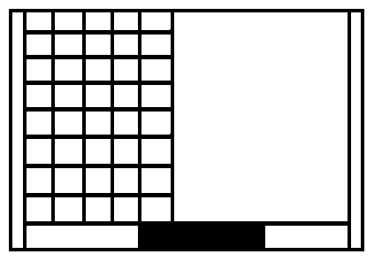 | L:5,928 mm  W:2,318 mm  H:2,259 mm | W:2,236 mm  H:2,278 mm | L:5,352 mm  W:2,118 mm | 6,118 LBS  2,775 KGS | 1,095 CU. FT.  31.0 CBM | 46,792 LBS  21,225 KGS
Artificial Tweendecks  An artificial tweendeck is reinforced to accommodate just about any shipment which is not suited for ordinary container stowage due to its weight or size. Several tweendecks may be combined on board vessel to provide safe and secure stowage of oversized or very heavy cargo. | 40’ ARTIFICIAL TWEENDECK  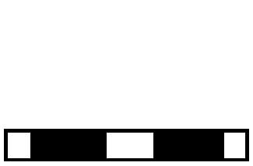 | L:12,065 mm  W:2,216 mm |  |  | 11,905 LBS  5,400 KGS |  | 85,979 LBS  39,000 KGS

